**HazPak E-Learning Portal**

**(For Trainee)**

Written by: Puah Yu Hao Louis

**Trainee User Guide**

# Logging In

**Step 1:**

Access the E-learning Portal Open your preferred web browser (e.g., Google Chrome, Mozilla Firefox). In the address bar, enter the URL provided by your organisation to access the E-learning portal. Press "Enter."

**Step 2:**

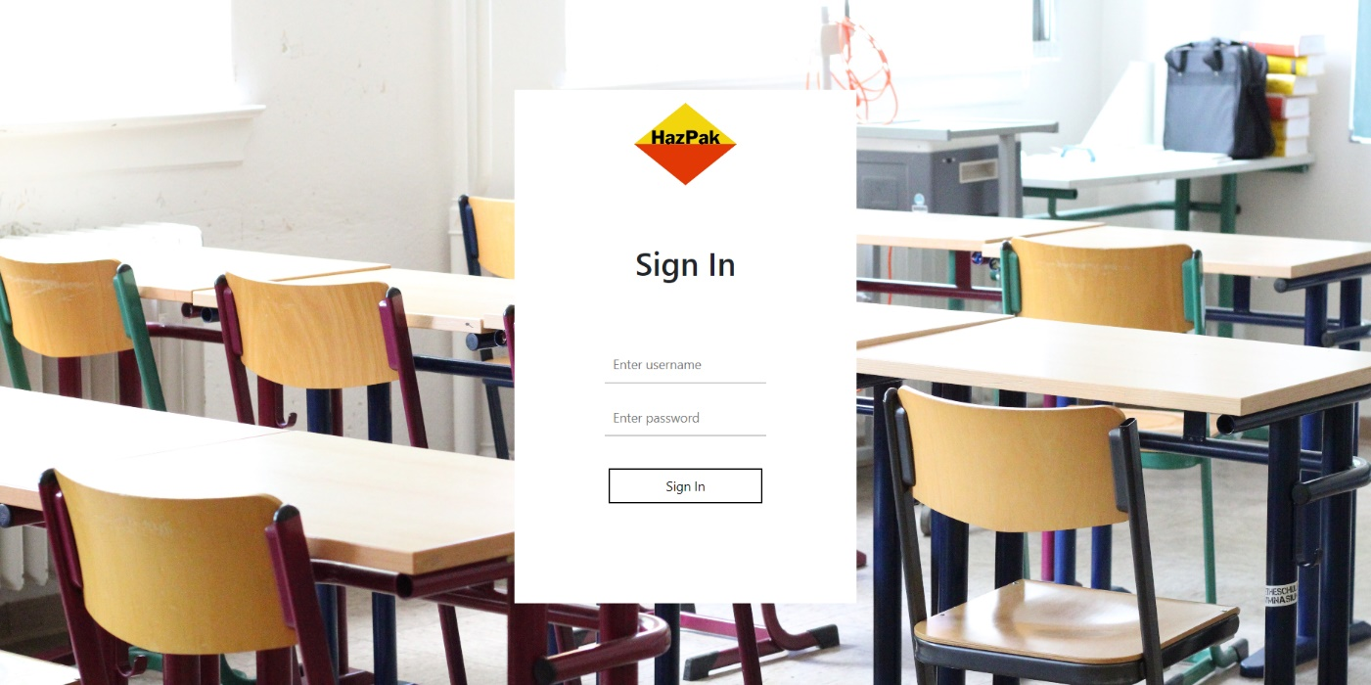

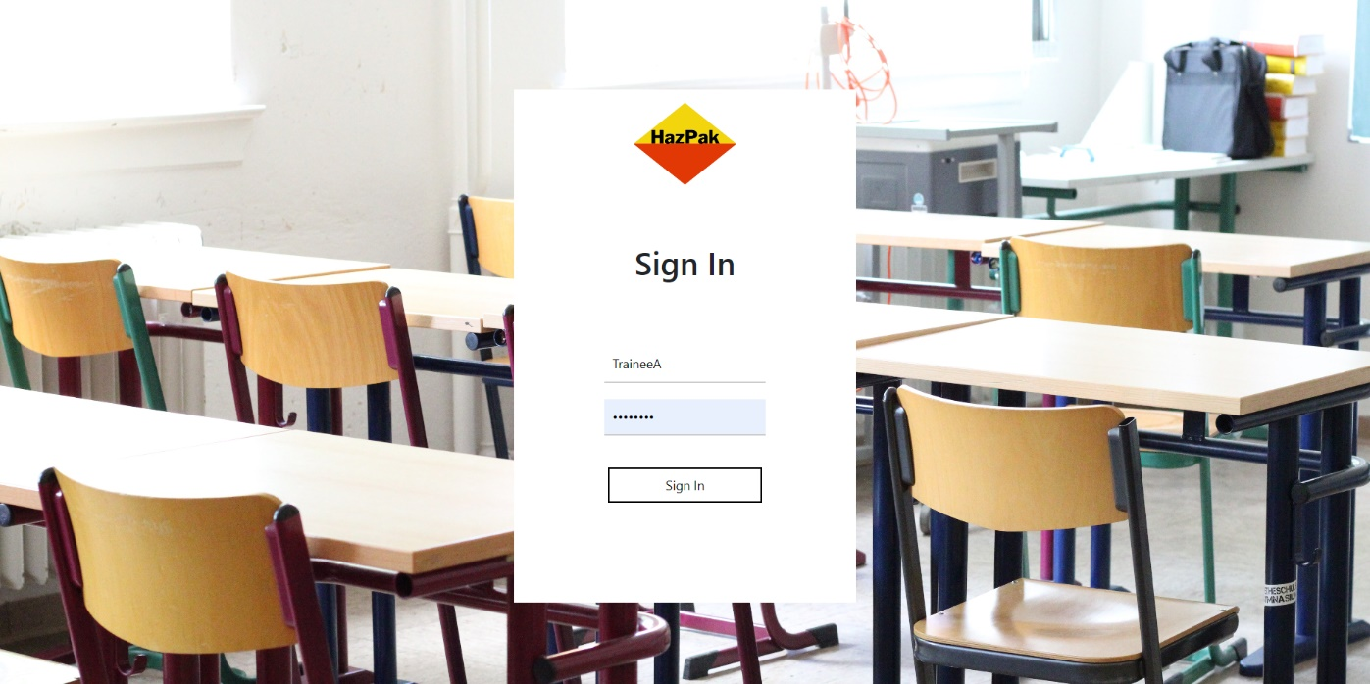

Enter Username and Password On the login page, you will see fields labeled "Username" and "Password." In the "Username" field, type in your unique username/identifcation. This will be provided by your organisation. In the "Password" field, enter your password. Passwords are case-sensitive, so make sure to enter it exactly as you created it.

**Step 3:**

Click "Sign In" Once you've entered your username and password.

# Take assessment

**Step 1:**

Look for the "Assessments" option in the navigation menu or on the dashboard. Click on it to access the Assessment page. Upon accessing the Assessment page, you'll see a container displaying the details of the current selected assessment. Above the container there is a dropdown list with a selection of assessments to take

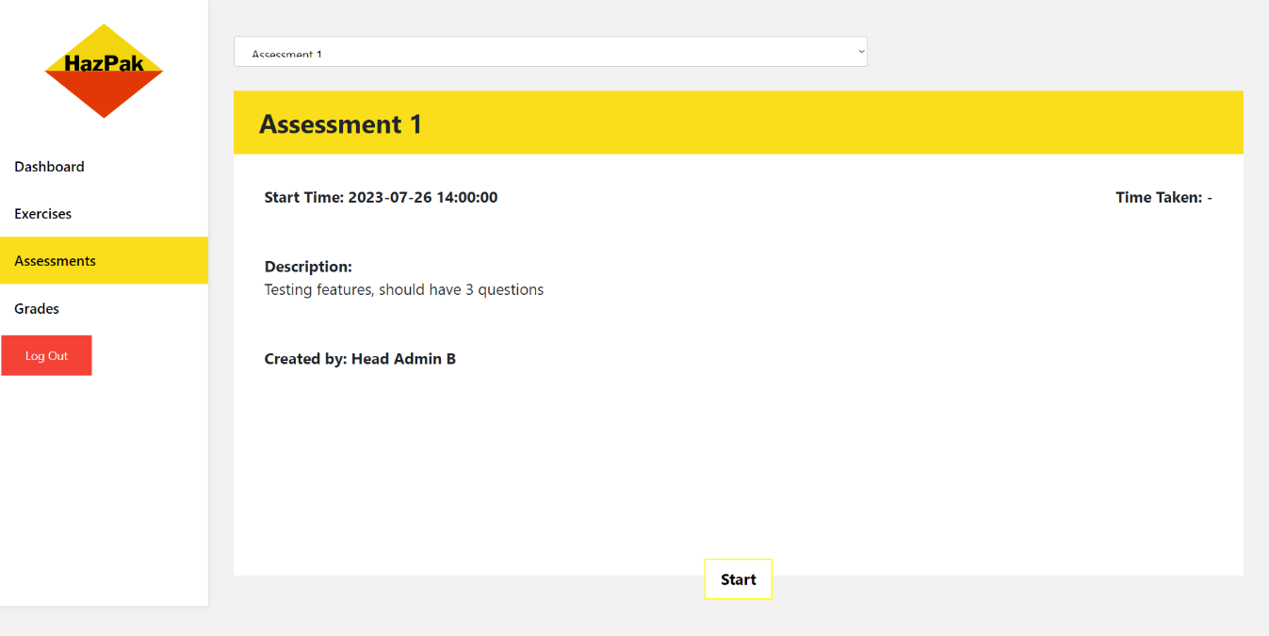

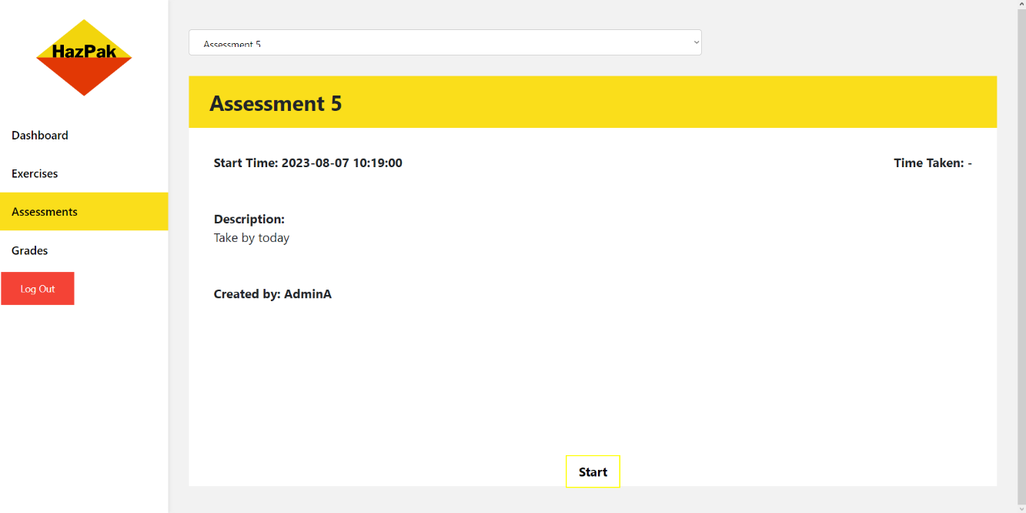

**Step 2 (Start Assessment):**

To begin the selected assessment, click on the start button which will redirect to to the takeAssessment page

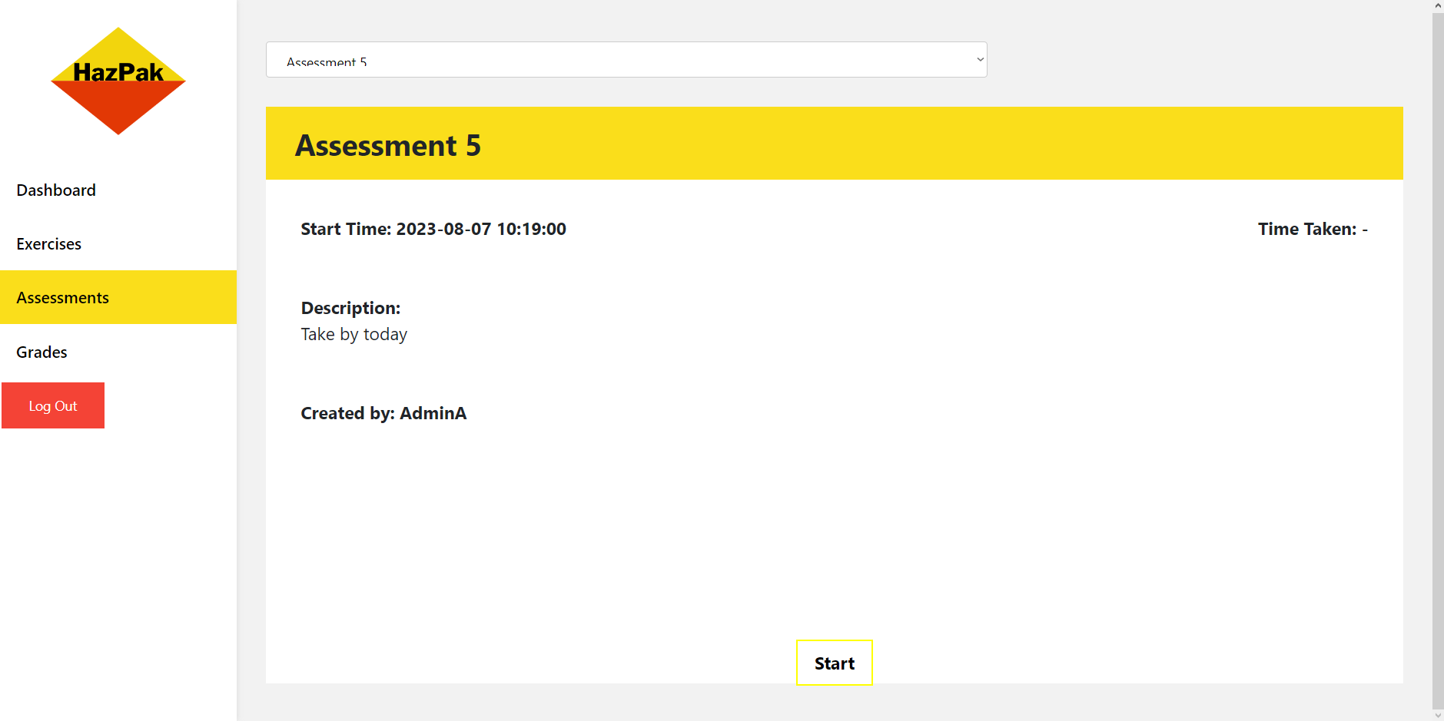

**Step 3 (Take Assessment):**

Attempt the questions in the Assessment

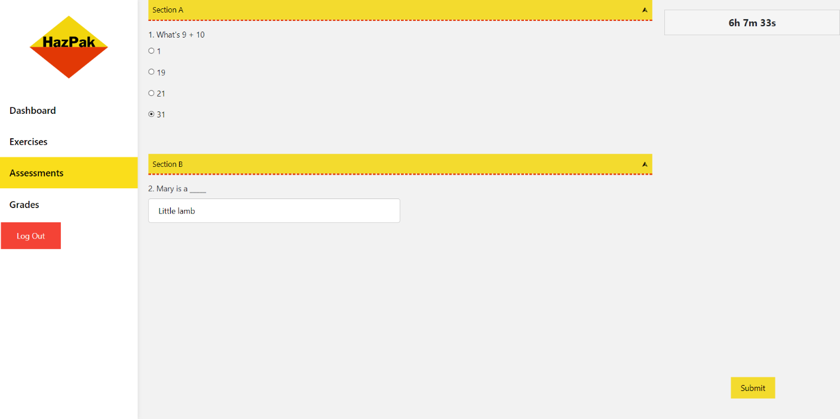

Once the information is entered, click the "Submit" button. Then you should see the questions you got correct



# Take Exercise

**Step 1:**

Look for the "Exercise" option in the navigation menu or on the dashboard. Click on it to access the Exercise page. Upon accessing the Exercise page, you'll see a container displaying the details of the current selected Exercise. Above the container there is a dropdown list with a selection of Exercise to take

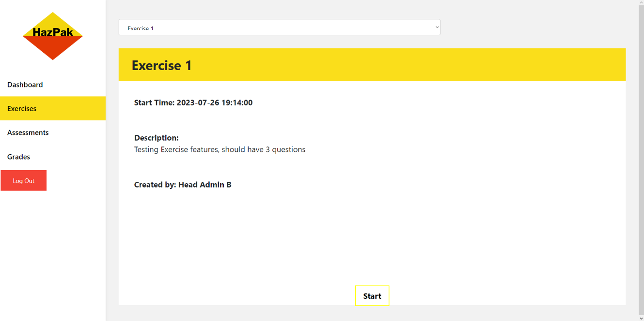

**Step 2 (Start** Exercise**):**

To begin the selected Exercise, click on the start button which will redirect to to the takeExercise page

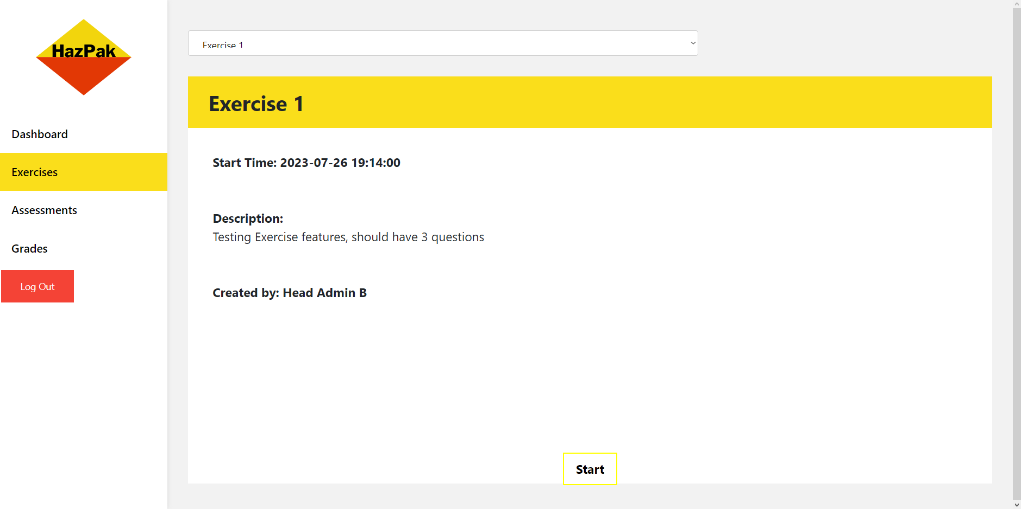

**Step 3 (Take** Exercise**):**

Attempt the questions in the Exercise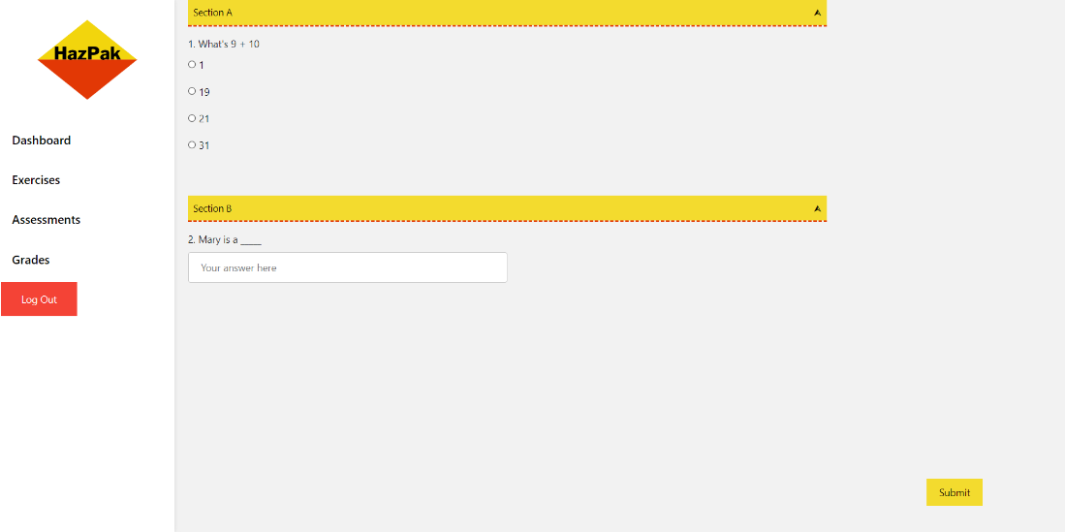

Once the information is entered, click the "Submit" button. Then you should see the questions you got correct



# View grades

Step 1: Go to Grades page

Step 2: View Grades

